SIMATS ENGINEERING

ASSESSMENT TOOL 1

COURSE NAME: Cryptography and Network Security COURSE CODE: CSA5113

COURSE OUTCOME COVERED

CO3: Examine cryptographic hash algorithms, digital signature schemes, and assess Kerberos and X.509 authentication frameworks for ensuring integrity, authentication, and non-repudiation.CO (BL4 , BL5)

Assessment Tool Weightage: 40%

QUESTIONS: 5 TOTAL MARKS: 25

EXPERIMENTS

Code of Conduct:

I D.Navadep/192371068 certify that this submission is my original work and that I have adhered to the guidelines specified for this assessment.
I understand that any violation of academic integrity rules will result in disciplinary action.

Signature of the student:

D.Navadeep
Annexure A Experiments

- Implement and compare MD5 and Secure Hash Algorithm (SHA-256) in Python by hashing multiple input messages. Analyze their collision resistance and performance differences.

- Develop a Python program to implement a Digital Signature scheme using RSA. Demonstrate message signing and signature verification, and analyze its effectiveness in ensuring integrity and authentication.

- Write a Python program to simulate HMAC (Hash-based Message Authentication Code) using a chosen hash function. Compare its security properties with a simple hash-based integrity check.

- Implement a simplified Kerberos authentication mechanism in Python to simulate ticket generation, distribution, and validation between a client and server. Analyze its effectiveness in preventing replay attacks.

- Develop a Python-based implementation of either the ElGamal or Schnorr digital signature scheme, and evaluate its security features compared to standard digital signature approaches.

RUBRICS FOR CALCULATION:

Criteria | Weightage | Level 4 – Exemplary | Level 3 –  Proficient | Level 2 –  Developing | Level 1 –  Beginning
Understanding of Concepts | 25 | Demonstrates thorough understanding and effectively integrates multiple  concepts/technologies | Good understanding with proper integration of most concepts | Basic understanding; limited or partial integration | Poor understanding; unable to integrate concepts
Experimental Design | 30 | Well-planned, systematic implementation with  optimal solution | Correct implementatio n with minor  issues | Basic implementation with errors or  inefficiencies | Incorrect or incomplete implementation
Use of Tools | 20 | Effective and advanced use of tools/technologies with proper  configuration | Appropriate use of tools with correct execution | Limited or inconsistent use of tools | Incorrect or  minimal use of tools
Analysis of Results | 15 | Insightful analysis with accurate interpretation and  validation of results | Good analysis with reasonable  interpretation | Basic analysis with limited insights | Poor or incorrect analysis of  results
Documentation | 10 | Clear, well-structured documentation with diagrams, code, and  results | Organized documentation with necessary  details | Basic documentation with missing  details | Poor or incomplete documentation

- Implement and compare MD5 and Secure Hash Algorithm (SHA-256) in Python by hashing multiple input messages. Analyze their collision resistance and performance differences.
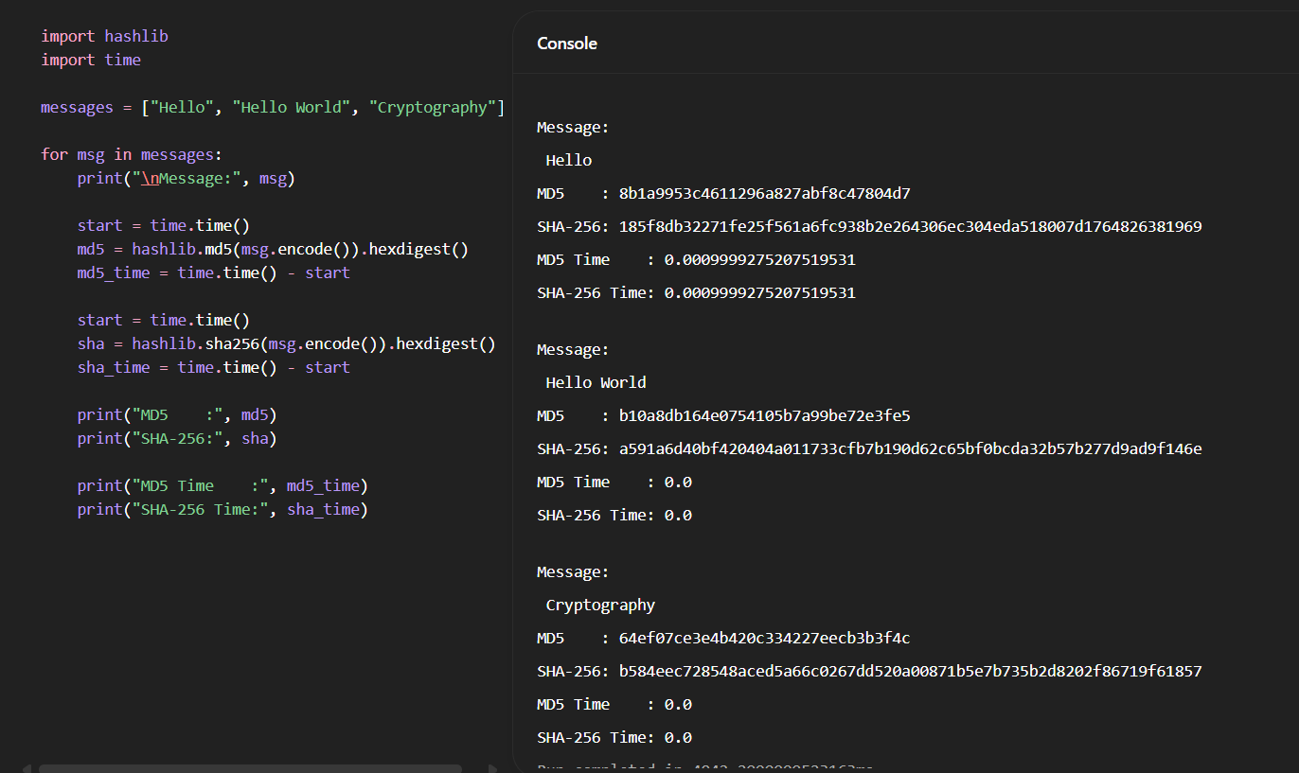

- Develop a Python program to implement a Digital Signature scheme using RSA. Demonstrate message signing and signature verification, and analyze its effectiveness in ensuring integrity and authentication.
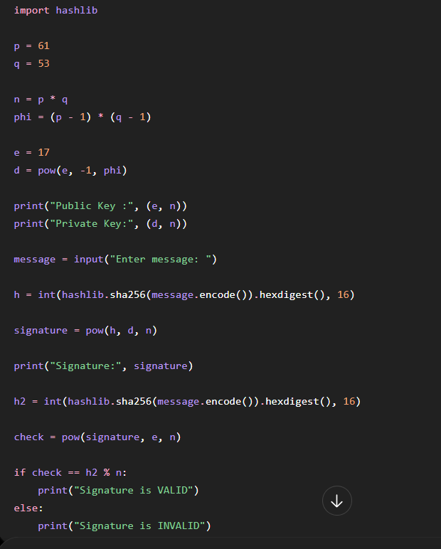

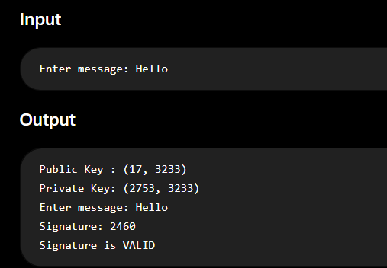

- Write a Python program to simulate HMAC (Hash-based Message Authentication Code) using a chosen hash function. Compare its security properties with a simple hash-based integrity check.

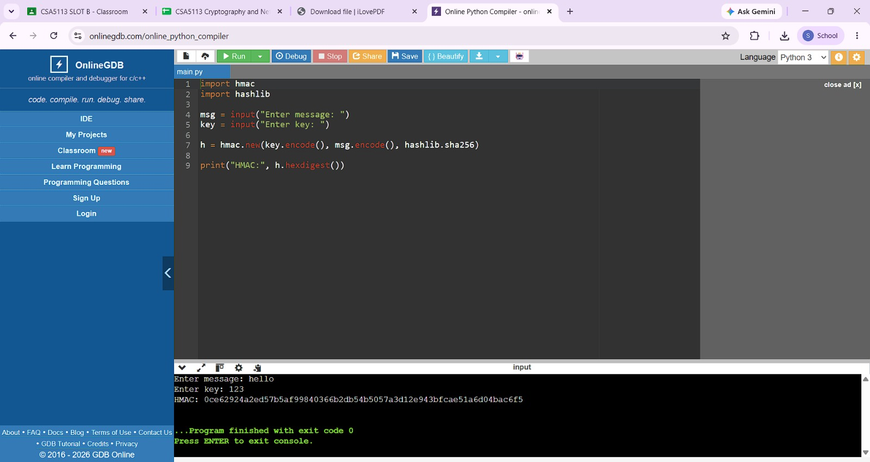

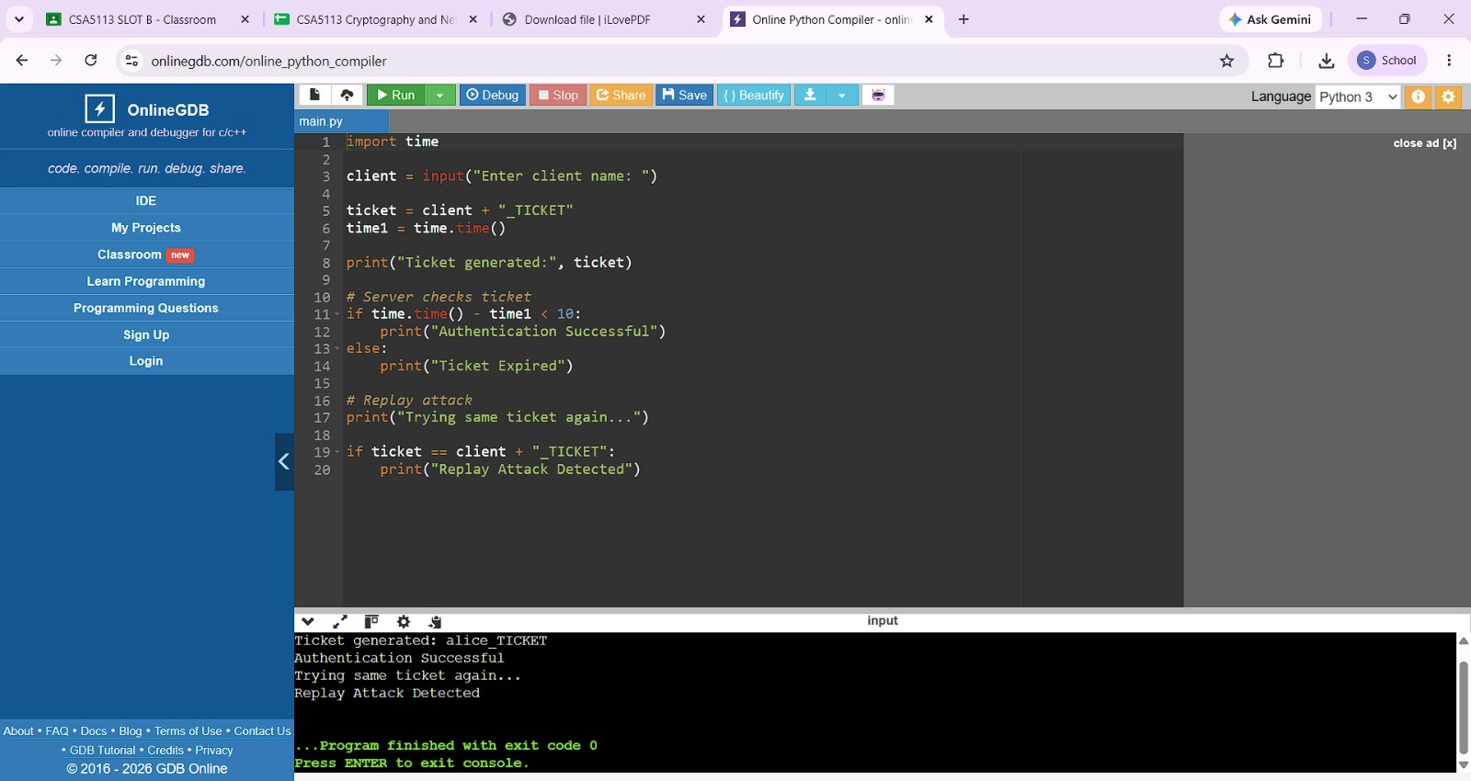
- Implement a simplified Kerberos authentication mechanism in Python to simulate ticket generation, distribution, and validation between a client and server. Analyze its effectiveness in preventing replay attacks.

- Develop a Python-based implementation of either the ElGamal or Schnorr digital signature scheme, and evaluate its security features compared to standard digital signature approaches.
